Lesson 11 Demo 4
Create a Container Instance
Objective: To create a Container Instance

Tools required: Azure account with administrator access

Prerequisites: None
Steps to be followed:
1. Going to the Azure portal
2. Clicking on Create a resource
3. Selecting Containers and click on Container Instances
4. Creating a Container Instance

Step 1: Going to the Azure portal

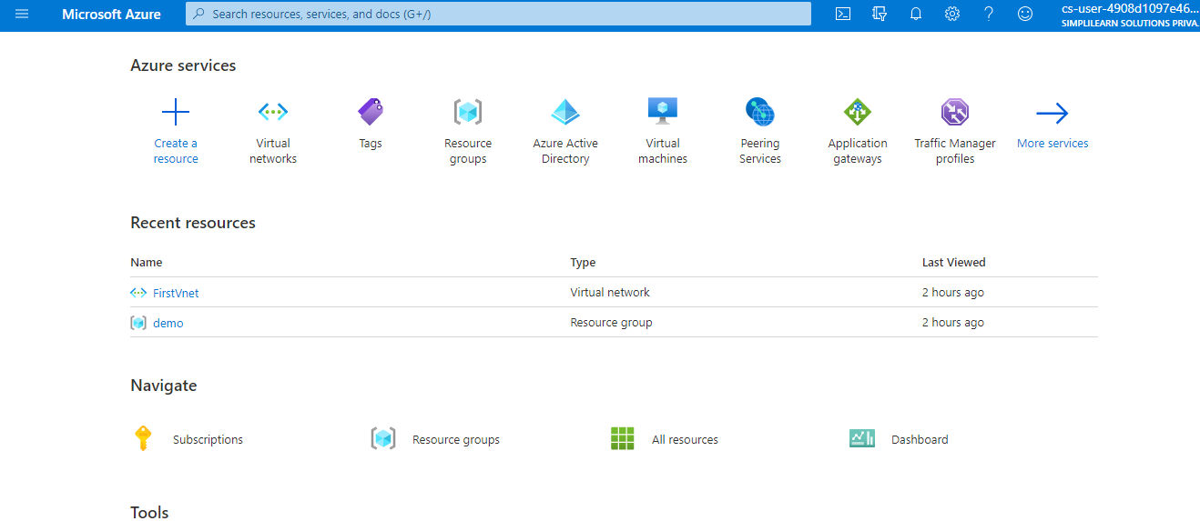

Step 2: Creating a resource
2.1 Select Create a resource

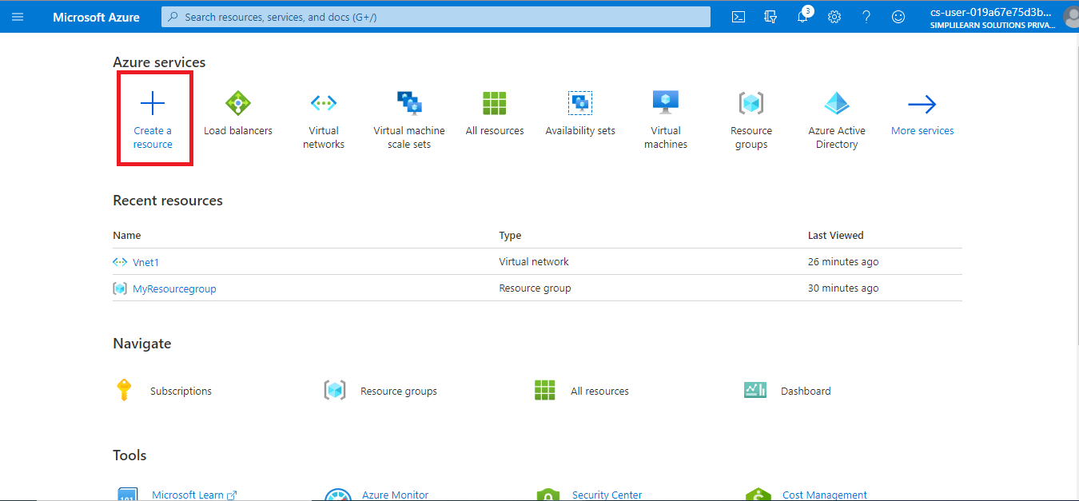

Step 3: Selecting Containers
3.1 Select Containers and then Container instances
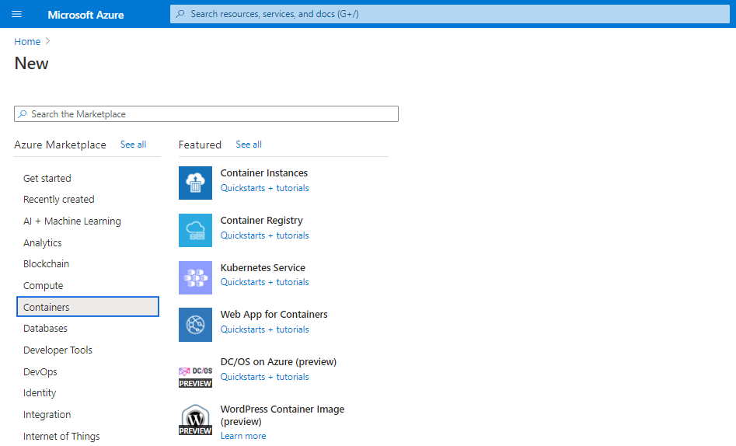
Step 4: Creating a Container Instance
4.1 On the Basics page, enter the following values
- Resource group
- Container name
- Container image text boxes

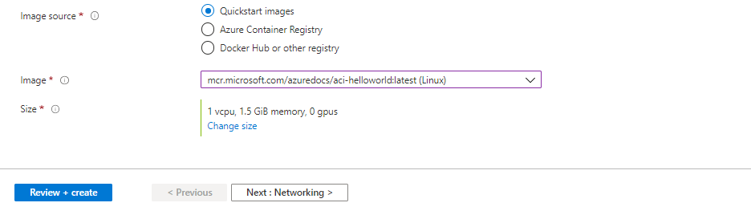

4.2 On the Networking page, specify a DNS name label for your container. The name must be unique within the Azure region where you create the container instance. Your container will be publicly reachable at <dns-name-label>.<region>.azurecontainer.io. If you receive a "DNS name label not available" error message, try a different DNS name label

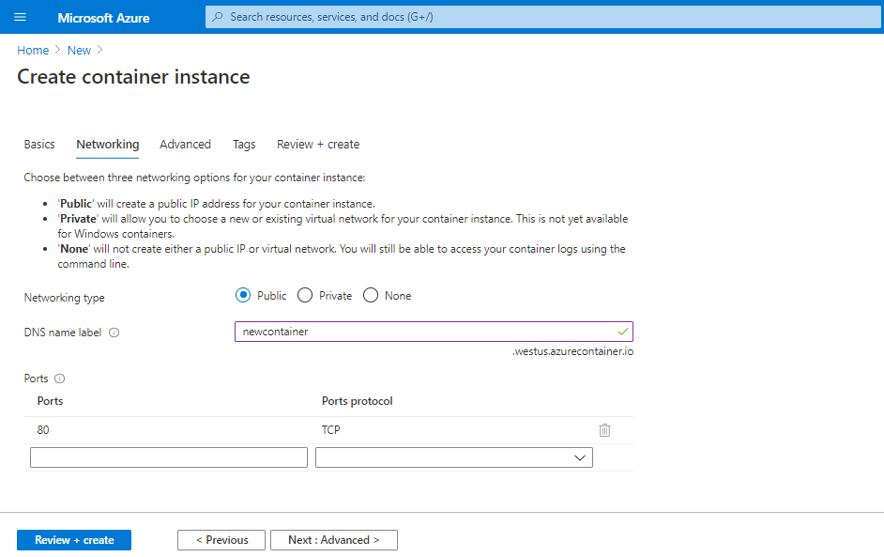

4.3 Leave the other settings as default and click on Review + create
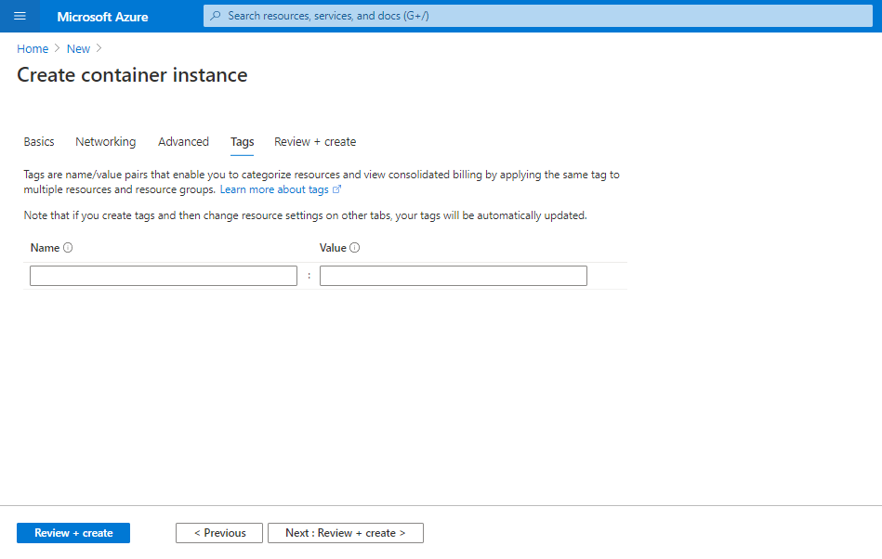

4.4 When the validation completes, a summary of the container's settings will be shown. Click on Create to submit your container deployment request

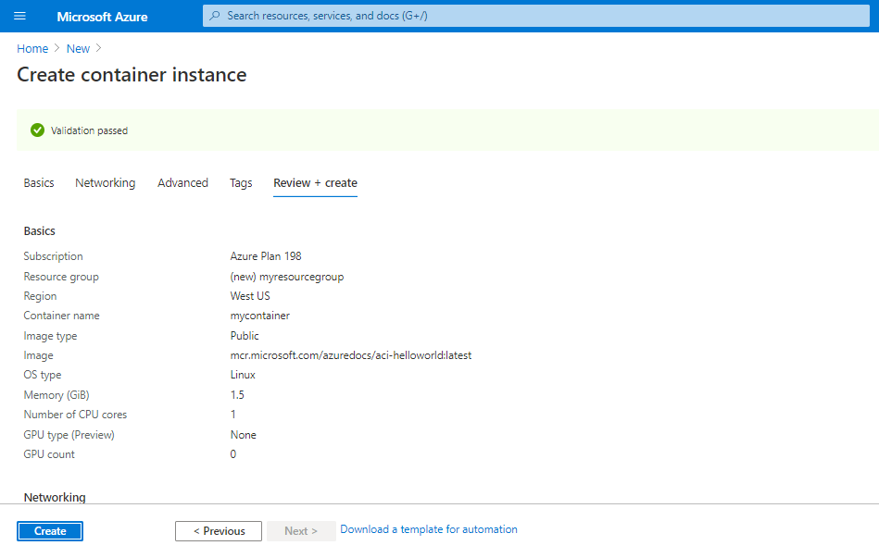

Your container instance will get deployed.

